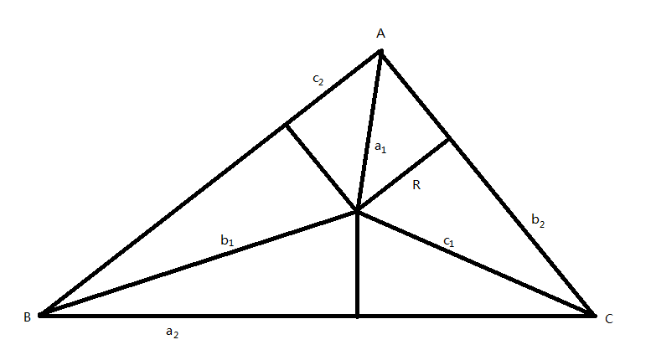

p = (a + b + c) / 2

S = (a + b + c) \* R / 2 = sqrt( p(p-a)(p-b)(p-c) )

所以R = sqrt( p(p-a)(p-b)(p-c) ) / p

R^2 = (p-a)(p-b)(p-c) / p

a1 ^ 2 = R^2 + c2 ^ 2

b1 ^ 2 = R^2 + a2 ^ 2

c1 ^ 2 = R^2 + b2 ^ 2

a = a2 + b2

b = b2 + c2

c = c2 + a2

p = a2 + b2 + c2

R^2 = a2b2c2 / (a2 + b2 + c2)

所求l = 2p + a1 + b1 + c1

(a1 + b1 + c1) ^ 2 = a1 ^ 2 + b1 ^ 2 + c1 ^ 2 + 2a1b1 + 2b1c1 + 2c1a1

a1^2 b1 ^2

= (2a2^2 b2^2 c2^2 + a2^4 b2 c2 + a2^3 b2^2 c2 + 3a2^3 b2 c2^2 + 3a2^2 b2 c2^3 + a2 b2^2 c2^3 + a2 b2 c2^4 + a2^4 c2^2 + a2^2 c2^4 + 2a2^3 c2^3) / (a2 + b2 + c2)^2

b1^2 c1^2

= (2a2^2 b2^2 c2^2 + a2^4 b2 c2 + 3a2^2 b2^3 c2 + 3a2^3 b2^2 c2 + a2 b2^4 c2 + a2^3 b2 c2^2 + a2 b2^3 c2^2 + a2^4 b2^2 + a2^2 b2^4 + 2a2^3 b2^3) / (a2 + b2 + c2)^2

c1^2 a1^2

= (2a2^2 b2^2 c2^2 + a2^2 b2^3 c2 + a2 b2^4 c2 + 3a2 b2^3 c2^2 + a2^2 b2 c2^3 + 3a2 b2^2 c2^3 + a2 b2 c2^4 + b2^4 c2^2 + b2^2 c2^4 + 2b2^3 c2^3) / (a2 + b2 + c2)^2